Participation in P-mec Exhibition 2021
at CPhI & P-MEC India (24-26 Nov 2021, India Expo Centre, Gr. Noida)
HALL-12 BOOTH No.-F-22

Offering complete range of Aseptic Valves for Sterile application in Pharma & Biotech Industries

New Arrivals

- Manual/Pneumatic Radial Type Flush Bottom Valves
- Angle Seated Valves in SS 316L with PID Controller

Standard Offerings

- Manual Diaphragm Valves (Investment Casted)
- Pneumatic Diaphragm Valves (Investment Casted)
- Manual Diaphragm Valves (Forged)
- Pneumatic Diaphragm Valves (Forged)
- Auto Dump Valves
- Angle Seated Valves (SS 304 / SS 316)
- “T” type & “L” type Forged Manual Block Valves
- “T” type & “L” type Forged Pneumatic Block Valves
- Multi- port Block Valves
Key Features :
- ASME BPE Compliant design & dimensions
- CE certified
- Non – Magnetic Design
- SIP 500 rated life durability
- 100% Homogeneous material
- Pore & crack free
- Non Raising design
- Excellent drainability
- Stock Restrictor
- Total close design easy to clean
- SIP & CIP Capability
- Traceability documents
Applications :

- Bioreactor skids
- Fermenters skids
- Buffer vessels
- Centrifuge skids
- Chromatography skids
- Process distribution
- PW & WFI skids

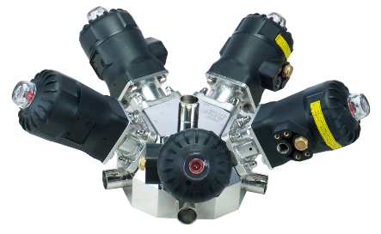
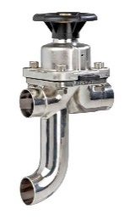
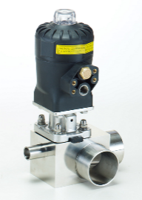

Specifications for above Valves:

Design Standard | ASME BPE
Testing Standard | EN 1266-1
Certification Standard | EN 10204
Diaphragm Compliance | USP CLASS VI Biological Reactivity  Test in Vitro & in Vivo  US FDA CFR 177.1550(PTFE)  US FDA CFR 177.26600(EPDM)
Construction | Non Magnetic
Valve Body | ASTM A351CF3M (SS-316L)
Bonnet | ASTM A315CF8 (SS-304)
Body Pressure Ratings | 16 Bars
Diaphragm | EPDM / PTFE Backed by EPDM
End Connections | T.C.End/Spigot as per BS 4825 /ASME BPE
Service | Water/Air/Steam/Slightly Aggressive fluids
Working Temp. | EPDM :120 °C  PTFE : 150 °C
Working Pressure | 10 Bars
Surface Finish | Internal : 0.2 to 0.4 Ra  External : 0.8Ra
Hand Wheel ( For Manual Operation) | Plastic PA6 GF 30% (Autoclavable)
Pneumatic Actuator | Spring Return Type
Body | Glass Filled Polyamide
Act. Working Signal Pressure | 3.5 to 6 Bar

